**INFORMation for external participants:**

**Accommodation:**

You can find information about accommodation on these web pages:

* [www.megaubytovanie.sk/bratislava](http://www.megaubytovanie.sk/bratislava)
* [http://www.booking.com/Ubytovanie-Bratislava](http://www.booking.com/searchresults.cs.html?label=short-Ubytovanie-Bratislava;sid=940169289de87bc76e11ff6ce0718fb8;dcid=4;class_interval=1&csflt=%7b%7d&dest_id=-840999&dest_type=city&dtdisc=0&hlrd=0&hyb_red=0&ifl=1&inac=0&nha_red=0&offset=0&redirected_from_city=0&redirected_from_landmark=0&redirected_from_region=0&review_score_group=empty&score_min=0&si=ai%2Cco%2Cci%2Cre%2Cla%2Cdi&ss=Ubytovanie-Bratislava&ss_all=0&ssb=empty&sshis=0&)

**Transport connections:**

* From the Central Railway Station Bratislava (*Hlavná stanica*): Take **trolleybus No. 210** to the Twin City *(7th bus station);* change for **Bus No. 88**,and get off at the 3rd bus stop University of Economics (*Ekonomická univerzita*).

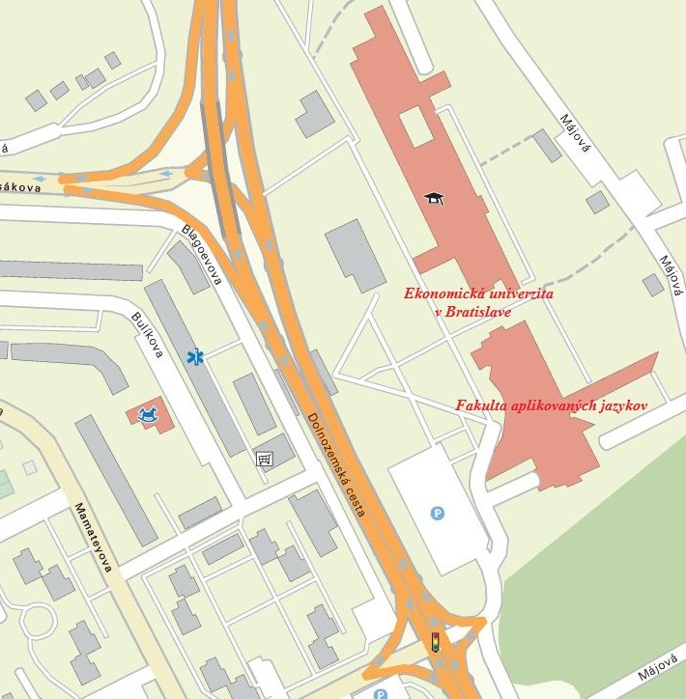

**Contact information:**

**Ing. Vladimír Hudek, CSc.**

Department for Science and Research

Faculty of Applied Languages

University of Economics in Bratislava

Dolnozemská cesta 1/b

852 35 Bratislava 5

E-mail: [vladimir.hudek@euba.sk](mailto:vladimir.hudek@euba.sk)

Tel.: +421 /2/ 6729 5229

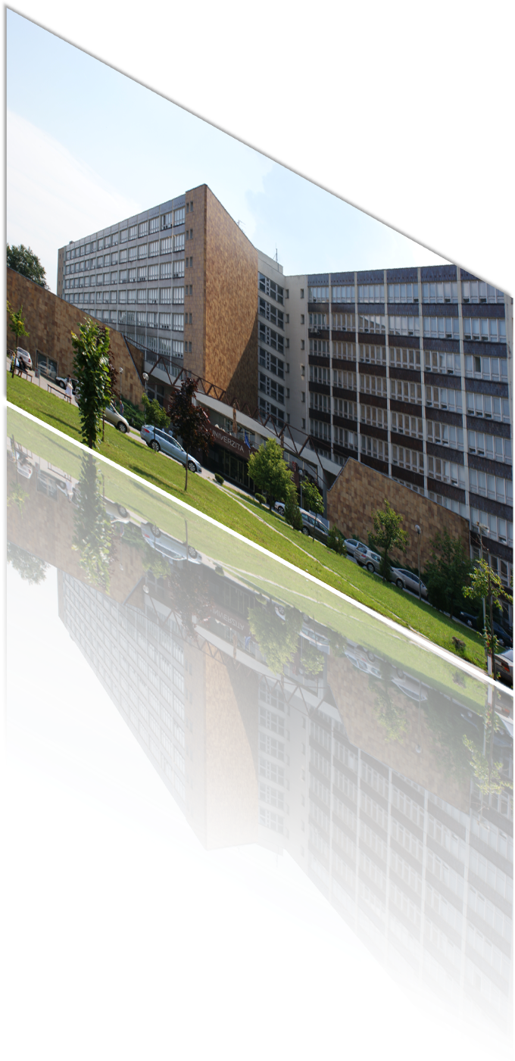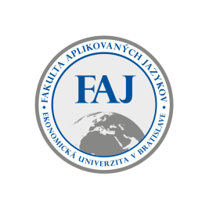

**Faculty of applied languages**

**University of Economics in Bratislava**

**INVITATION**

**to the 10th International Scientific Conference**

**Foreign Languages**

**in Changing Times**

**held on**

**November 8, 2019**

**Conference Venue**

University of Economics in Bratislava

Dolnozemská Rd. 1/b

852 35 Bratislava 5

**Room: Lecture Hall, Building 1**

# AIMS OF THE CONFERENCE

* create a platform for discussing the latest trends in foreign language teaching
* present the findings of research work in the realm of languages and cultures
* present the prospects of research activities in terms of the latest trends in the development of linguistics and literary studies
* support interdisciplinary character of research activities
* react to current social, political and cultural issues

# CONFERENCE TOPIC AREAS

* linguistics and linguo-didactics
* cultures and communication
* area studies and literature
* theory and practice of translation and interpretation
* didactics of languages for specific purposes

# CONFERENCE LANGUAGE/ PROCEEDINGS

* Slovak, English, Czech, German, French, Russian, Spanish, and Italian

## Scientific committee

**Chair:**

doc. PhDr. Radoslav Štefančík, MPol., Ph.D.

**Members:**

Prof. PhDr. Lívia Adamcová, PhD doc. Mgr. Spišiaková Mária, PhD.

doc., Ing. Katarína Seresová, PhD. PhDr. Roman Kvapil, PhD.

PhDr. Tatiana Hrivíková, PhD PaedDr. Eva Stradiotová, PhD.

PhDr. Ildikó Némethová, PhD. doc. PhDr. Daniela Breveníková, CSc.

PhDr. Mária Bláhová, PhD. PhDr. Iveta Rizeková, PhD.

Mgr. Ingrid Kunovská, PhD. Dr. Katalin Varga Kiss, PhD. (Hungary)

Univ.- Prof. Dr. Irena Zavrl, PhD. (Austria) doc., Mgr. Tomáš Káňa, PhD. (Czech

Republic)

**ORGANIsing committee**

**Chair**: PaedDr.Žaneta Pavlíková, PhD.

**Members:**

Ing. Vladimír Hudek, CSc., Mgr. Tomas Maier, PhD., Mgr. Iveta Maarová, PhD., Mgr. Jozef Štefčík, PhD., PhDr. Milena Helmová, PhD. .

.

**Important deadlines**

Application including an abstract: **by September 10, 2019**

Payment of the conference fee: **by September 30, 2019**

Submission of the full text of the paper: **by October 30, 2019**

**Conference fee:**

Participant/ presenter of the paper:  **60 €**

Publishing the paper without participation: **40 €**

**Registration fee covers:** refreshments, lunch, costs of publishing the conference proceedings on a CD.

**INSTRUCTIONS FOR PAYMENTS**

**IBAN**: SK47 8180 0000 0070 0008 0671

**Reference number:** 019106002200

**SWIFT:** SPSRSKBA

**References:** write name of the person for whom the payment is effected

**OUTLINE OF THE CONFERENCE PROGRAMME**

**November 8, 2019 (Friday)**

08:30 – 09:00 Registration of participants

09:00 – 09:10 Conference opening

009:10 – 10:00 Ambassadors´ speeches

10:00 – 10:15 Coffee break

10:15 – 11.00 Plenary lectures

11:15 – 12:30 Parallel sections

12:30 – 13:30 Lunch

13:30 – 15.30 Parallel sections

15.30 – 15.45 Coffee break

15.45 – 18.30 Parallel sections

18.30 – 19.00 Closing of the conference

Please forward your paper to: [vladimir.hudek@euba.sk](mailto:vladimir.hudek@euba.sk)