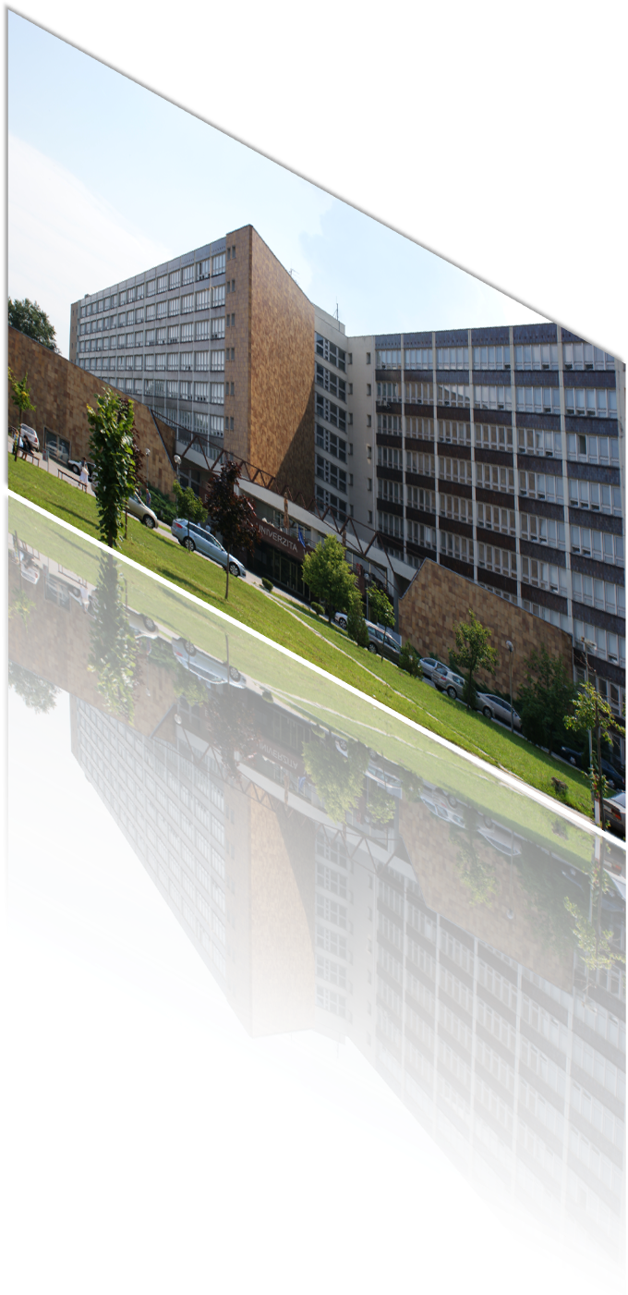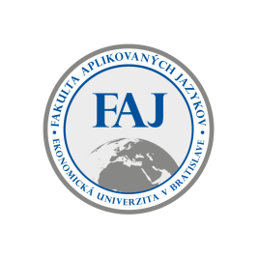

**INVITATION**

**to the 14th International Scientific Conference**

**Foreign Languages**

**in Changing Times**

**held on**

**November 14 – 15, 2024**

**At the faculty of applied languages**

**University of Economics in Bratislava**

**Room: Meeting room, Building 1**

# AIMS OF THE CONFERENCE

* create a platform for discussing the latest trends in foreign language teaching
* present the findings of research work in the realm of languages and cultures
* present the prospects of research activities in terms of the latest trends in the development of linguistics and literary studies
* support interdisciplinary character of research activities
* react to current social, political and cultural issues

# CONFERENCE TOPIC AREAS

* linguistics and linguo-didactics
* cultures and communication
* area studies and literature
* theory and practice of translation and interpretation
* didactics of languages for specific purposes

# CONFERENCE LANGUAGE/ PROCEEDINGS

* Slovak, English, Czech, German, French, Russian, Spanish, and Italian

## Scientific committee

**Chair:**

doc. PhDr. Radoslav Štefančík, MPol., Ph.D.

**Members:**

prof. Elena Markova, DrSc. doc. Mgr. Spišiaková Mária, PhD.

doc. Marina Vazanová, PhD. Mgr. Andrea Tureková, PhD.

doc. Mgr. Ing. Katarína Seresová, PhD. PaedDr. Eva Stradiotová, PhD.

PhDr. Tatiana Hrivíková, PhD. Dr. habil. PhDr. Ildikó Némethová, PhD.

Dr. Katalin Varga Kiss, PhD. (Hungary) Mgr. Ingrid Kunovská, PhD.

doc. Mgr. Tomáš Káňa, Ph.D. (Czechia) PhDr. Roman Kvapil, PhD.

Univ.Prof. Dr. Irena Zavrl, PhD. (Austria) Mgr. Silvia Adamcová, PhD.

Mgr. Jozef Štefčík, PhD.

**Organizing Committee:**

PaedDr. Žaneta Pavlíková, PhD. – chair

Mgr. Linda Krajčovičová, PhD.

**IMPORTANT DEADLINES**

Application including an abstract: **by September 30, 2024**

Notification of abstract acception **by October 10 2024**

Payment of the conference fee: **by October 30, 2024**

Submission of the full text of the paper:  **by November 30, 2024**

**Please forward your paper to:** [**zaneta.pavlikova@euba.sk**](mailto:zaneta.pavlikova@euba.sk)

**Conference fee:**

Participant/ presenter of the paper: **72 € (including VAT)**

Publishing the paper without participation: **48 € (including VAT)**

**Registration fee covers refreshments, lunch, costs of publishing the conference proceedings.**

**INSTRUCTIONS FOR PAYMENTS**

**SWIFT:** SPSRSKBA

**IBAN**: SK34 8180 0000 0070 0007 4503

**Variable symbol:** 106000124

**References:** Write the name of the person(s) for whom the payment is effected

**Contact information:**

**PaedDr. Žaneta Pavlíková, PhD.**

Fakulta aplikovaných jazykov EU v BA

Dolnozemská cesta 1/b

852 35 Bratislava 5

E-mail: [zaneta.pavlikova@euba.sk](mailto:zaneta.pavlikova@euba.sk)

Tel.: +421 /2/ 6729 5217