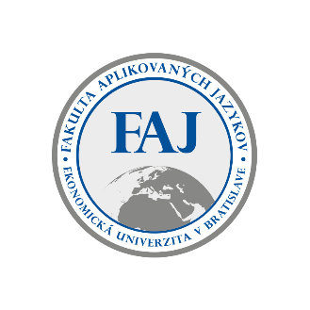

VEDECKÉ ZASADNUTIE

dňa 29.11.2024 o 13.00 na E1.06

na tému

Glory to Ukraine’: a corpus-based analysis of President V. Zelenskyy´s political speeches in wartime

Prednáša: doc.Mgr. Svitlana [GOLOSHCHUK](https://faj.euba.sk/katedry/katedra-interkulturnej-komunikacie/clenovia-katedry/goloshchuk-svitlana), PhD.

